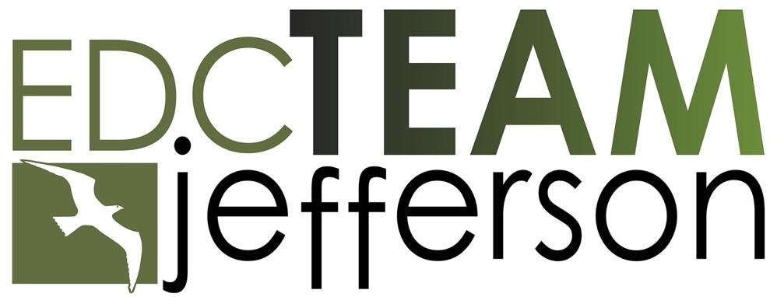

Economic Development Associate
Job Description

Application Coordinator  Laura Brooks  EDC Team Jefferson  360-379-4693  385 Benedict St. Ste 2A, Port Townsend, WA 98368  Admin@EDCTeamJefferson.org | Salary:  $60,000–$70,000, depending on experience  Schedule:  Full-time, non-exempt  Location:  Port Townsend, WA with hybrid flexibility

Position Summary
EDC Team Jefferson is hiring an Economic Development Associate to help advance new jobs, business growth, and private investment across Jefferson County. This is an early-career role for someone who would like to build a long-term career in economic development, planning, infrastructure, or place-based investment. The successful candidate will bring strong writing, analytical, and outreach skills and will be expected to grow quickly into a meaningful contributor to the EDC’s strategic-plan work.
Organization Overview
EDC Team Jefferson is the State of Washington’s designated Associate Development Organization for Jefferson County. We work with Jefferson County, the City of Port Townsend, the Port of Port Townsend, Jefferson County PUD, private employers, nonprofit partners, and state and regional economic development organizations to support a stronger and more resilient local economy.

Key Responsibilities

Economic Development Project Support
- Support projects that advance new jobs, business growth, housing, and private investment in Jefferson County.
- Help move priority economic development areas from planning toward implementation, beginning with the Irondale-Port Hadlock Urban Growth Area and expanding to other locations as assigned.

Site and Development Research
- Help identify properties with potential for business, housing, commercial, or light industrial development.
- Gather and organize information on ownership, zoning, utilities, road access, infrastructure, environmental conditions, and known development barriers.
- Use maps, public records, planning documents, site visits, and partner input to help assess which sites may be ready for action and which need additional work.

Business and Partner Outreach
- Support outreach to landowners, existing businesses, prospective businesses, developers, public agencies, infrastructure providers, and regional economic-development partners.
- Help coordinate site visits, business conversations, partner briefings, and follow-up meetings.
- Help new and prospective businesses understand the local landscape, including permitting, utilities, workforce resources, and public partners.

Written Materials, Convenings, and General Support
- Draft clear, practical materials such as site summaries, opportunity profiles, one-page briefs, maps, slide decks, and briefing memos.
- Help summarize common obstacles to investment and potential solutions for public and infrastructure partners.
- Support EDC convenings and partner meetings, including agendas, briefing materials, meeting notes, follow-up, logistics, partner communication, research, documentation, and reporting tied to EDC projects and strategic-plan deliverables.

Qualifications

Required
- Bachelor’s degree in a relevant field such as urban or regional planning, economics, geography, business and real estate, public administration, or environmental studies.
- Strong written and analytical skills.
- Comfort with data, maps, spreadsheets, public records, planning documents, and technical information; willingness to build GIS and site-analysis skills.
- Comfort with site visits, fieldwork, and travel to meetings across Jefferson County.
- Good judgment, discretion, follow-through, and the ability to operate in a small-team environment.
- Demonstrated interest in building a sustained career in economic development, community development, or public policy.

Preferred
- Strong knowledge of Jefferson County and the North Olympic Peninsula.
- One to three years of relevant experience, including internships, in economic development, planning, port or infrastructure work, public policy, or a related field.
- Familiarity with Washington’s Growth Management Act, comprehensive planning, zoning, permitting, utilities, infrastructure planning, or county and city development processes.
- Basic understanding of site selection, real-estate development, housing development, light industrial development, commercial development, infrastructure funding, or place-based investment tools such as Opportunity Zones or New Markets Tax Credits.

Compensation & Benefits
- Salary: $60,000-$70,000 annually, depending on experience.
- Health insurance: 100% employer-paid Platinum-tier medical, dental, and vision premiums.
- Retirement: SIMPLE IRA with 5% employer match.
- Paid time off: 15 vacation days in Year 1; 20 days in Year 2; 25 days in Year 3 and thereafter; 12 paid holidays in 2026; sick leave accrued at 1 hour per 25 hours worked.
- Professional development: Funding for International Economic Development Council (IEDC) coursework, travel to relevant conferences, and a dedicated annual training stipend.
- Work location: Based at the EDC’s Port Townsend office with regular fieldwork across Jefferson County. Hybrid work flexibility is available after onboarding, compatible with project needs.

How to Apply
Interested candidates should submit a resume and cover letter to: admin@edcteamjefferson.org.

Application deadline: June 10, 2026. Applications will be considered on a rolling basis.

EDC Team Jefferson is an equal opportunity employer and prohibits discrimination and harassment of any kind. We encourage applications from all qualified individuals, including women, people of color, LGBTQ+ individuals, and those with disabilities.

